Membership And Words & Wine Form 2015

Name:
Address:
City, State Zip:
Email: |  |  | Phone:
Friends of the Catonsville Library Membership |  | $25 $50 $75  $100 $200  Other: ______ |  | Total:
Words & Wine Tickets $30/Person:  (Your tickets will be waiting for you at Words & Wine front table.) |  | # of Tickets: |  | Total:
50th Anniversary Canvas Book Bag  $5 Donation  Visit www.catonsvillelibraryfriends.org/ to see the tote |  | # of Canvas Bags: |  | Total:
 |  | (Please include your email above so that we can inform you when your canvas tote is ready for pick up.)
 |  | Total:
----------------------------------------------------------------------------------------------------
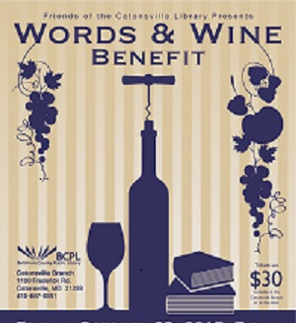 |  | Join the Friends of the Catonsville Library  At Our  Words & Wine Annual Benefit  Friday, October 23, 2015 at 7 PM  Mingle with fellow book-lovers.  Engage in conversation with local authors.  Sip on wine varietals.  Savor gourmet cheeses and desserts.  Listen to jazz guitarist Bob Margolis.  Tickets $30  At the Library or By Mail | $31.60 Online
Authors confirmed include:
Jason Tinney and Debra Roffman
Louis Diggs, Sue Eisenfeld, Barbara Glickman, Erin Hagar, Danuta Kosk-Kosicka, Kate Nolan,
Antero Pietelia, Rebecca Remington and David Shackelford
Visit www.catonsvillelibraryfriends.org for more authors.

Books available for sale and signing.
Keep up-to-date - Like us on Facebook - www.facebook.com/CatonsvilleLibraryFriends
Note: This is an Adult Only event.

