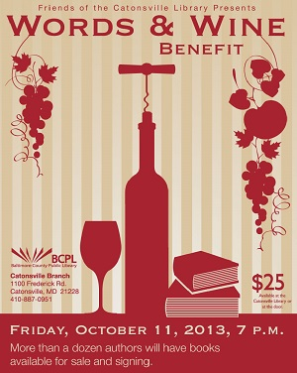 | Join the Friends of the Catonsville Library  At Our Annual  Words & Wine Benefit  Friday, October 11, 2013 at 7 PM  Mingle with fellow book-lovers.  Engage in conversation with local authors.  Sip on wine varietals.  Savor gourmet cheeses and desserts.  Listen to jazz guitarist Bob Margolis.  Tickets $25
Authors confirmed include:
Raphael Alvarez, Charles Belfoure, Sheri Booker, Jonathon Scott Fuqua, Eric & Natalia Goodman, Stephen Hunter, Bryan MacKay, Sujita Massey, Jen Michalski, Richard O’Mara, David Shackelford, and Dan Toomey.
Books available for sale and signing.
Keep up-to-date - Like us on Facebook - www.facebook.com/CatonsvilleLibraryFriends
--------------------------------------------------------------------------------------------------------------------------------------
Friends of the Catonsville Library
Words & Wine Ticket Form
Name:
Address:
City, State Zip:
Phone:
Email:
Words & Wine Tickets $25/Person: | # of Tickets: | Total:
50th Anniversary Canvas Book Bag  (Additional $10 Donation)  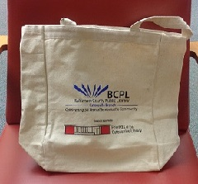 | # of Canvas Bags: | Total:
 | Total:
Please make checks out to “Friends of The Catonsville Library” and drop off the form and check at the library or mail to 1100 Frederick Rd, Catonsville, MD 21228

